Nashville Real Estate Price Modeling and Benchmarking
Allen Gao
University of Massachusetts Amherst
MIE622
Michael Prokle
Introduction
A real estate company was looking to make a huge investment in the growing Nashville area. To do so, a dataset about recent estate sales was given to be used to build models such as decision tree, random forest, gradient boosting, and linear regression. The dataset included 31 variables describing characteristics such as land use, property location, assessed value, acreage, finished area, year built, number of bedrooms and bathrooms, and sale date. Before the dataset could be used to train these models, however, it needed to be cleaned and prepared to ensure that the analysis was based on accurate, consistent, and relevant information. However, some variables and their meanings were unclear and required careful examination before deciding whether to retain or remove them from the analysis.
Data Cleansing
The first step was to delete the Unnamed: 0 and Unnamed: 0.1 columns because they were only row indices and did not provide useful information for predicting sale prices. After these columns were removed, 103 exact duplicate records were identified and deleted to prevent repeated transactions from influencing the models. Once this was completed, the dataset was examined for recognized missing values and question marks that might have been used as missing-data placeholders. No question-mark placeholders were found; however, several variables contained substantial amounts of missing information. The column names were then standardized to make them easier to reference consistently throughout the analysis. The variables such as sold_as_vacant and multiple_parcels_involved_in_sale, which originally contained “Yes” and “No” responses, were converted into binary numerical variables. “No” was set to 0 and “Yes” was set to 1 so that the models could process these predictors consistently. The sale year, month, and quarter were extracted as separate predictors so that the models could account for changes in property prices over time, after which the original date variable was removed.
Several variables were removed because they were identifiers, nearly the same as other variables, or were unlikely to improve the sale-price predictions. The parcel_id, legal_reference, owner_name, address, suite or condo number, and image reference were removed because they were mainly identifiers for individual properties or transactions rather than general characteristics that could reliably predict the prices of the properties. The state and city variables were also removed because they were largely redundant with property-location information in the property_city variable. The original sale_date was deleted after extracting its useful time components. Finally, land_value and building_value were removed while total_value was retained as a combined assessment measure, reducing redundant information and potential multicollinearity.
After the unnecessary variables were removed, the remaining text-based predictors were standardized to prevent formatting inconsistencies from creating separate categories. Extra spaces within each value were reduced to a single space, leading and trailing spaces were removed, and empty strings were converted into recognized missing values. The continuous target variable, sale_price, was then separated from the predictor variables. The data were divided into 70% training and 30% testing datasets using a random state of 42 to make the results reproducible. This split was completed before replacing missing values to prevent information from the testing dataset from influencing the training process. Even though most of the numerical values were missing for approximately half of the observations, they were retained because they represented important property characteristics that could contribute to sale-price predictions. The missing values were replaced with the training-set medians for both the training and test sets to preserve the available observations while limiting the influence of extreme property values. However, this approach may reduce some of the natural variation in these predictors and should be used with caution. Among the categorical predictors, property_city contained only 159 missing values, representing a small proportion of the complete dataset. Therefore, these missing entries could reasonably be replaced with the mode calculated from the training data, allowing the observations to be retained without substantially altering the variable’s overall distribution. However, other categorical predictors such as tax_district and foundation_type contained more missing information. Replacing all of those values with their mode could have incorrectly assigned thousands of properties to the most common categories and distorted their distributions. Their missing values were therefore labeled as “Unknown” to improve overall data quality by preserving the fact that the original information was unavailable, retaining the observations, and avoiding distorting the data. Once all missing values had been treated, the predictor sets were checked again to confirm that no missing values remained.
Once there were no missing values, the categorical variables in the training and test data were converted into numerical dummy variables through one-hot encoding using the get_dummies function, which drops the first category from each variable to reduce redundant predictors. The testing columns were rearranged to match the training columns exactly, so it doesn’t mess the model up. The continuous numerical predictors such as acreage and total value were standardized using StandardScaler. It learns the mean and standard deviation of each predictor from the training data and uses those values to transform both the training and test sets so that the variables are measured on comparable scales. The binary value columns were exempt from it to preserve their straightforward interpretation as “No” and “Yes”. After all of that, the training and test predictor sets’ shape was checked to make sure they had the same number of columns to ensure each model would receive a consistent set of predictors during training and testing.
Linear Regression Analysis
To build the linear regression model, a constant was added to the training predictors to allow the model to estimate a baseline sale price rather than forcing the regression line through zero. The OLS model was then fitted using the processed training predictors and their corresponding sale prices. The summary of the model can then be printed, where we see the training R^2 and other predictors with their stats, such as their p-values and coefficients. The model achieved a training R^2 of .135, which means it only explains 13.5% variation in the sale prices. When evaluated using the test data with the test predictors, a constant was added to it, and the corresponding sale prices, it only achieved a test R^2 of .120. With those R^2 values being low for the training and test, it shows that it wasn’t a good fit and was inaccurate. This weak performance may have resulted partly from the large amount of missing property information, a nonlinear relationship that the linear model could not capture, or there were too many predictors that was made by the OneHotEncoding.
To identify the variables that were significantly associated with sale prices, a data frame was created containing each predictor’s name, coefficient, and p-value. The constant was removed, and only predictors with p-values below the 0.05 significance level were retained. The coefficients showed the direction and estimated size of each relationship, while the p-values indicated whether there was sufficient statistical evidence that the relationship was different from zero. They are then sorted from lowest to highest p-values to show the most to least significant variables in the data frame, which produces Figure A1. Figure A1 presents the five most statistically significant predictors of sale price in the linear regression model, based on their p-values. These variables provided the strongest statistical evidence of an association with sale price. The multiple parcels involved in the sale had the largest influences on the prices, which might be due to it being a binary variable where 1 is coded as “Yes” and 0 coded as “No”. The reason it could be so high is that the multiple-parcel transaction is that it includes multiple properties within one total sale price. The second variable influential to the prices is the sold as vacant binary variable, similar to the most influential variable. It showed a huge effect on the prices of properties; if it was vacant, the sale prices of those properties would be about 4 hundred thousand dollars less than non-vacant properties. In 3rd, 4th, and 5th place that drove the prices were the total value, the property_city Nashville, and sale_ year variables. These seem to drive up the prices most. Based on the p-values, these five variables are most influential in driving the prices.
Decision Tree Analysis
The decision tree regressor was initially constructed with a max depth of 10. Limiting the tree’s depth would help control its complexity and reduce the risk of overfitting the training data. The model was then fitted using the encoded predictors and corresponding sale prices before being evaluated on both the training and test datasets. The evaluation was done by using the trained model’s predict function that received the encoded predictors from both datasets and returned an estimated sale price for every observation. These predictions were then compared with the corresponding actual sale prices to calculate the training and testing R^2 values using the r2_score function. It was able to achieve training and testing R^2 values of 0.474 and .471, respectively. Compared to the linear regression, the decision tree performed a lot better in terms of accuracy and fit performance. The reason is probably that it doesn’t assume that every predictor has a constant linear relationship with sale price, could work effectively with the large number of encoded predictors, and could handle missing data better.
To find which variables drive the prices the most in the decision tree model, the model’s feature importance values were placed in a DataFrame alongside their corresponding predictor names and sorted from highest to lowest. These importance values measured how much predictors reduced the prediction error across the tree’s splits. Predictors with higher values had greater influence on the model’s decision. When Figure A2 was produced, it showed that the five most important predictors that drive the sale prices the most in the decision tree were sale_month, land_use_RESIDENTIAL CONDO, sale year, multiple_parcels_involved_in_sale, and total_value. Compared to linear regression, it seems that sale_month and land_ use_RESIDENTIAL CONDO have only replaced sold_as_vacant and property_city-NASHVILLE in the top five variables that drive the prices, while others still remained in the top five that drive the prices in the model. The reason it may be different is that the decision tree processes the data differently compared to linear regression and that it uses different values to see which values would drive sale prices.
Random Forest Analysis
The random forest regression model was first initialized with forty decision trees and a random_state of 0 to make a more stable prediction and result reproducible. The random forest model was fitted with encoded training predictors and with their corresponding sale prices before being evaluated on the training and testing datasets. After training, the model’s score function was applied to both the training and testing datasets, where their R^2 score would be .500 and .498, respectively. Compared to the other previous models, random forest was able to achieve the highest accuracy among the models and a slightly better fit compared to the decision tree, but greater than the linear regression, as well as the R^2 difference between the two datasets is only .002.
Similar to the decision tree, the random forest model’s feature importance values were placed in the data frame with their corresponding predictor names and sorted from highest to lowest that was printed as Figure A3. In Figure A3, it showed that the random forest’s five most important predictors that drive the sale prices were sale_month, land_use_RESIDENTIAL CONDO, sale_year, multiple_parcels_involved_in_sale, and total value. These same five predictors were identified by the decision tree and appeared in the same order but had slightly different importance values. The differences between the random forest and linear regression results were similar to those observed for the decision tree. This consistency strengthens the evidence that transaction timing, condominium land use, multiple-parcel sales, and assessed property value contributed substantially to the tree-based models’ sale-price predictions.
Gradient Boosting Analysis
The gradient boosting regression model was configured similarly to the random forest, using 40 decision trees and a random state of 0 for reproducibility. The gradient boosting model built its tree sequentially compared to the random forest that trains its tree independently and averages their predictions. The model was then fitted using the encoded training predictors and corresponding sale prices. After the gradient boosting model was trained, its score function wans applied to the encoded training and testing predictors with their corresponding actual sale prices, which returned the R^2 value for each dataset. The gradient boosting model achieved a training R^2 of 0.330 and a testing R^2 of 0.312. With the testing R^2 value of .312, it is less accurate to decision tree and random forest but more accurate than linear regression. It also had about a 0.018 difference between the two R^2 values, which made it the lowest-fitted model compared to the other previous models.
To identify the predictors that contributed most to the gradient boosting model’s sale-price predictions, the same general procedure used for the decision tree and random forest was followed. The model’s feature importance values were paired with their corresponding predictor names in a dataframe and sorted from highest to lowest, which was printed out to create Figure A4. Figure A4 showed that gradient boosting was more similar to the decision tree and random forest models, sharing four of the same five leading predictors. The primary difference was that sold_as_vacant appeared in the gradient boosting model’s top five instead of sale_year. The rankings also changed slightly, as land_use_RESIDENTIAL CONDO became the most important predictor, followed by sale_month. Gradient boosting also shared three of its five leading predictors with linear regression: multiple_parcels_involved_in_sale, total_value, and sold_as_vacant. However, land_use_RESIDENTIAL CONDO and sale_month replaced property_city_NASHVILLE and sale_year in the top five.
Model Benchmarking and Final Recommendation
To benchmark the last three models, they were done in the same code cell so that they could be compared to each other better. The three models were first stored in a dictonary with their selected parameters. Empty containers were created to store the fitted models and their results. A loop was then used to train and evaluate every model with the same encoded training and testing datasets. For each model, a timer was started before fitting it to the training predictors and corresponding sale prices. The trained model then predicted the test sale prices, after which the timer was stopped. Therefore, the recorded computation time included model training and test-set prediction.
Predictions were also generated for the training data so that training and testing R² values could be calculated. Training R² measured how closely each model fit the data used to build it, while testing R² measured its predictive fit on unseen observations. Comparing these values helped identify possible overfitting. RMSE placed greater weight on larger prediction errors. Each fitted model and its metrics were stored for later analysis. Finally, the results were converted into a DataFrame, ranked from highest to lowest testing R², and formatted to make the model comparison easier to interpret, as shown in Figure A5.
Based on those three models, as shown in Figure A5, the real estate company should pick the random forest model as it demonstrated the strongest overall predictive performance. It achieved the highest testing R² of 0.498 and the lowest RMSE of approximately $621,501. Its R² gap was also only about 0.002, indicating that its performance remained consistent between the training and testing datasets with a great fit. Although random forest had the longest computation time among the other two models, most companies prioritize the accuracy and the fit of the model more than just the speed to support high-value investment decisions rather than make real-time predictions. Therefore, the random forest’s higher testing R² and lower MAE and RMSE justified its additional computation time.
Conclusion
Overall, the models produced mixed but useful results when predicting Nashville property sale prices. Linear Regression proved to be the weakest model, while the stronger results from the tree-based models indicated that housing prices were influenced by nonlinear relationships and interactions among the predictors. Random forest performed best, achieving the highest testing R² and the lowest MAE and RMSE while maintaining a very small generalization gap. The datasets should have given more details about each variable. The dataset could have provided more complete and current information about each property so that it would be easier to clean the data up. Many important characteristics, including finished area, year built, bedrooms, bathrooms, foundation type, and exterior wall, were missing in half of the observations. This may have contributed to the models’ relatively limited predictive performance because the imputed values could not fully preserve the original variation among individual properties. The company could use its predictions to prioritize properties whose asking prices appear lower than their estimated market values. However, because the model explained only about half of the variation in sale prices and still produced substantial errors, its results should be combined with current comparable sales, professional inspections, and local market expertise before making investment decisions.
Appendix
Figure A1
Statisically Significant Predictors in Linear Regression Model
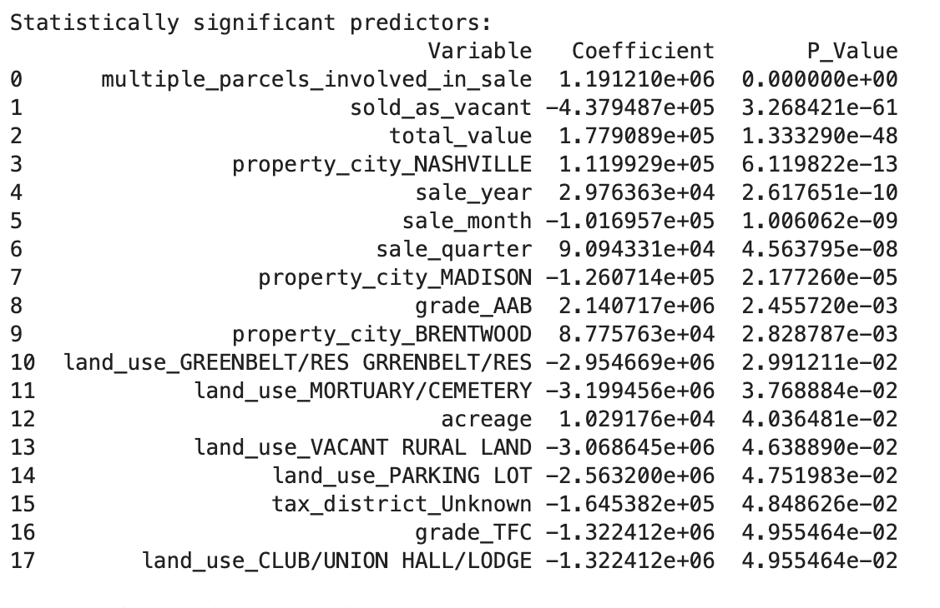
Note: Predictors with p-values below 0.05 were considered statistically significant. Coefficients show the direction and estimated magnitude of each relationship with sale price.
Figure A2
Five Most Important Predictors in the Decision Tree Regression Model
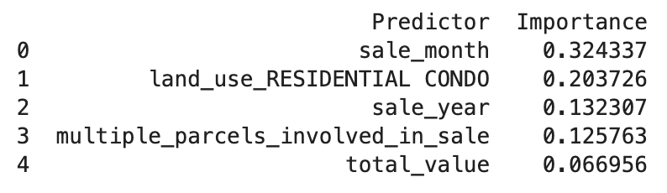
Note: Feature-importance scores measure how much each predictor reduced prediction error across the tree’s splits. Higher scores indicate greater contributions to the model’s predictions.
Figure A3
Five Most Important Predictors in Random Forest Regression Model
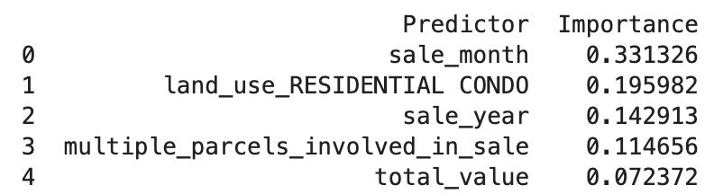
Note: Similar to Figure A2, Feature-importance scores measure how much each predictor reduced prediction error across the tree’s splits. Higher scores indicate greater contributions to the model’s predictions.
Figure A4
Five Most Important Predictors in the Gradient Boosting Regression Model
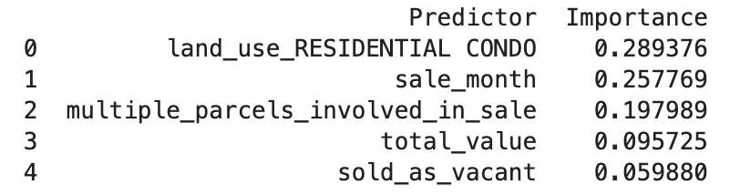
Note: Similar to Figures A2 and A3, Feature-importance scores measure how much each predictor reduced prediction error across the tree’s splits. Higher scores indicate greater contributions to the model’s predictions.
Figure A5
Benchmarking Results for Decision Tree, Random Forest, and Gradient Boosting Models
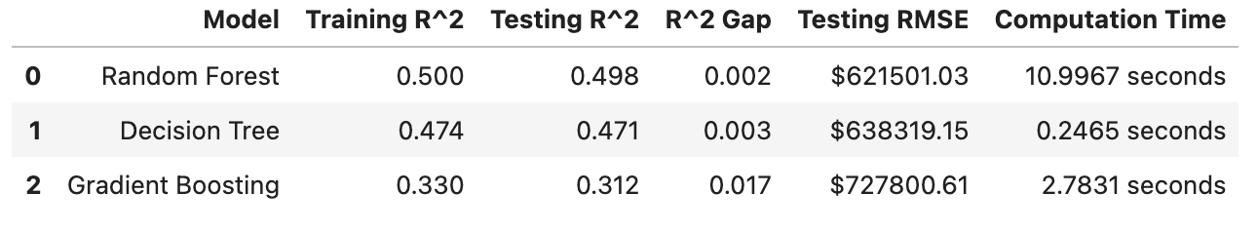
Note. Higher testing R² values indicate stronger accuracy, while smaller R² gaps indicate more consistent training and testing performance and better fit. Lower RMSE indicates smaller prediction errors, while shorter computation times indicate greater processing efficiency.

